OOP PROJECT

Name:
Azan Sohail
Qasim Imran
ID:
F2023266599
F2023266639

Project Name:
University Management System (UMS)

Project Description :

This project simulates a university management system where users can manage information about departments, faculty members, courses, students, semesters, buildings, classrooms, timeslots, libraries, books, staff members, course materials, exams, and clubs. It allows users to add and display various entities related to a university environment.

Features of OOP Used in the Project :

1. Encapsulation:
Classes like `Person`, `Student`, `Faculty`, `Department`, `Course`, `Semester`, `University`, etc., encapsulate related data (attributes) and behaviors (methods) into cohesive units.

2. Inheritance:
Inheritance is used to create specialized classes based on general classes. For example, `Student` and `Faculty` inherit from `Person`, inheriting its `name` attribute and `display ()` method.

3. Polymorphism:
Polymorphism is demonstrated through method overriding, where derived classes (`Student`, `Faculty`) provide their own implementation of the `display ()` method, which is originally defined in the `Person` class.

4. Abstraction:
Abstraction is used to hide complex implementation details and only expose necessary features to the user. For instance, `University`, `Course`, `Semester`, etc., provide interfaces (`display ()`) to interact with their data without revealing internal workings.

5. Composition:
Classes like `Classroom`, `Book`, `CourseMaterial`, `Exam`, etc., demonstrate composition where objects are composed of other objects (e.g., a `Classroom` contains a `Building`, a `Book` contains a `Library`, etc.).

6. Aggregation:
Aggregation is shown through relationships like `University` containing `Department` and `Semester`, `Department` containing `Faculty`, etc. These relationships represent a "has-a" relationship rather than a "is-a" relationship.

UML DIAGRAM :

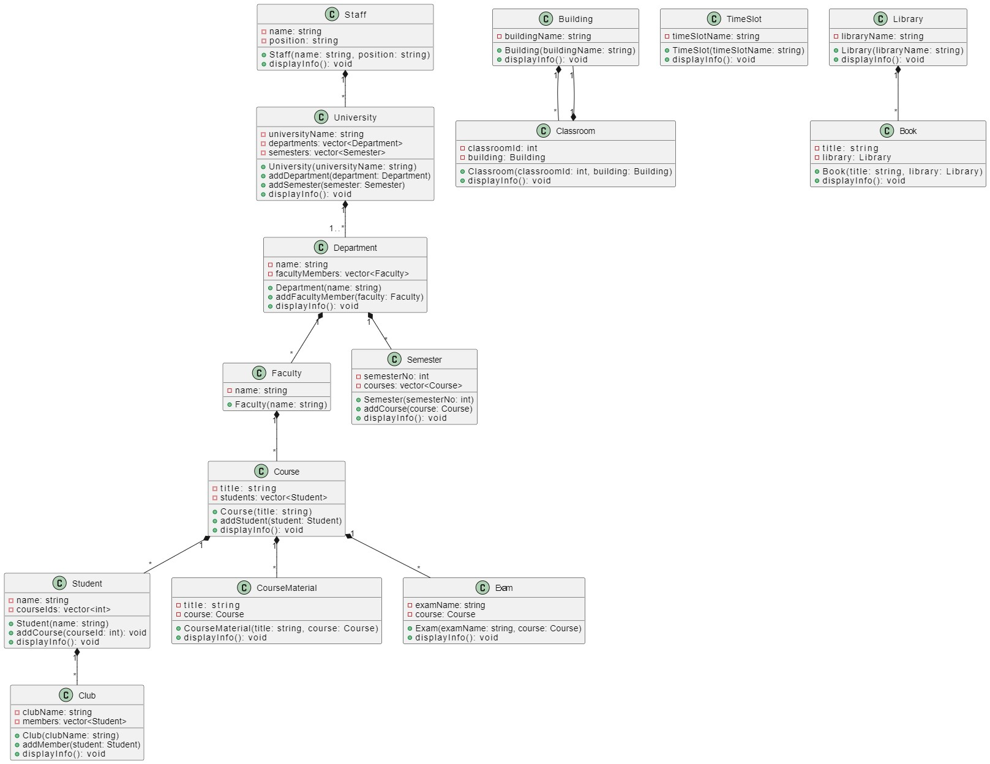

Project Code :
#include <iostream>
#include <string>
#include <vector>

using namespace std;

class Person {
protected:
string name;
public:
Person(string name) : name(name) {}
virtual void display() const {
cout << "Name: " << name << endl;
}
};

class Student : public Person {
private:
vector<int> courseIds;
public:
Student(string name) : Person(name) {}
void addCourse(int courseId) { courseIds.push_back(courseId); }
void display() const override {
Person::display();
cout << "Courses: ";
for (int i = 0; i < courseIds.size(); i++) {
cout << courseIds[i] << " ";
}
cout << endl;
}
};

class Faculty : public Person {
public:
Faculty(string name) : Person(name) {}
};

class Department {
private:
string name;
vector<Faculty> facultyMembers;
public:
Department(string name) : name(name) {}
void addFacultyMember(Faculty faculty) { facultyMembers.push_back(faculty); }
void display() const {
cout << "Department: " << name << endl;
cout << "Faculty Members: " << endl;
for (int i = 0; i < facultyMembers.size(); i++) {
facultyMembers[i].display();
}
}
};

class Course {
private:
string title;
vector<Student> students;
public:
Course(string title) : title(title) {}
void addStudent(Student student) { students.push_back(student); }
void display() const {
cout << "Course: " << title << endl;
cout << "Students: " << endl;
for (int i = 0; i < students.size(); i++) {
students[i].display();
}
}
};

class Semester {
private:
int semesterNo;
vector<Course> courses;
public:
Semester(int semesterNo) : semesterNo(semesterNo) {}
void addCourse(Course course) { courses.push_back(course); }
void display() const {
cout << "Semester: " << semesterNo << endl;
cout << "Courses: " << endl;
for (int i = 0; i < courses.size(); i++) {
courses[i].display();
}
}
};

class University {
private:
string universityName;
vector<Department> departments;
vector<Semester> semesters;
public:
University(string universityName) : universityName(universityName) {}
void addDepartment(Department department) { departments.push_back(department); }
void addSemester(Semester semester) { semesters.push_back(semester); }
void display() const {
cout << "University: " << universityName << endl;
cout << "Departments: " << endl;
for (int i = 0; i < departments.size(); i++) {
departments[i].display();
}
cout << "Semesters: " << endl;
for (int i = 0; i < semesters.size(); i++) {
semesters[i].display();
}
}
};

class Building {
private:
string buildingName;
public:
Building(string buildingName) : buildingName(buildingName) {}
void display() const {
cout << "Building: " << buildingName << endl;
}
};

class Classroom {
private:
int classroomId;
Building building;
public:
Classroom(int classroomId, Building building) : classroomId(classroomId), building(building) {}
void display() const {
cout << "Classroom: " << classroomId << ", Building: ";
building.display();
}
};

class TimeSlot {
private:
string timeSlotName;
public:
TimeSlot(string timeSlotName) : timeSlotName(timeSlotName) {}
void display() const {
cout << "TimeSlot: " << timeSlotName << endl;
}
};

class Library {
private:
string libraryName;
public:
Library(string libraryName) : libraryName(libraryName) {}
void display() const {
cout << "Library: " << libraryName << endl;
}
};

class Book {
private:
string title;
Library library;
public:
Book(string title, Library library) : title(title), library(library) {}
void display() const {
cout << "Book: " << title << ", Library: ";
library.display();
}
};

class Staff : public Person {
private:
string position;
public:
Staff(string name, string position) : Person(name), position(position) {}
void display() const override {
Person::display();
cout << "Position: " << position << endl;
}
};

class CourseMaterial {
private:
string title;
Course course;
public:
CourseMaterial(string title, Course course) : title(title), course(course) {}
void display() const {
cout << "CourseMaterial: " << title << ", Course: ";
course.display();
}
};

class Exam {
private:
string examName;
Course course;
public:
Exam(string examName, Course course) : examName(examName), course(course) {}
void display() const {
cout << "Exam: " << examName << ", Course: ";
course.display();
}
};

class Club {
private:
string clubName;
vector<Student> members;
public:
Club(string clubName) : clubName(clubName) {}
void addMember(Student student) { members.push_back(student); }
void display() const {
cout << "Club: " << clubName << endl;
cout << "Members: " << endl;
for (int i = 0; i < members.size(); i++) {
members[i].display();
}
}
};

int main() {
string universityName;
cout << "Enter University Name: ";
getline(cin, universityName);
University uni(universityName);

string deptName;
cout << "Enter Department Name: ";
getline(cin, deptName);
Department dept(deptName);

string facultyName;
cout << "Enter Faculty Name: ";
getline(cin, facultyName);
Faculty faculty(facultyName);
dept.addFacultyMember(faculty);

uni.addDepartment(dept);

int semesterNo;
cout << "Enter Semester Number: ";
cin>>semesterNo;
cin.ignore();
Semester semester(semesterNo);

string courseTitle;
cout << "Enter Course Title: ";
getline(cin, courseTitle);
Course course(courseTitle);

string studentName;
cout << "Enter Student Name: ";
getline(cin, studentName);
Student student(studentName);

int courseForStudent;
cout << "Enter Course ID for Student: ";
cin >> courseForStudent;
cin.ignore();
student.addCourse(courseForStudent);

course.addStudent(student);

semester.addCourse(course);

uni.addSemester(semester);

string buildingName;
cout << "Enter Building Name: ";
getline(cin, buildingName);
Building building(buildingName);

int classroomId;
cout << "Enter Classroom ID: ";
cin >> classroomId;
cin.ignore();
Classroom classroom(classroomId, building);

string timeSlotName;
cout << "Enter TimeSlot Name: ";
getline(cin, timeSlotName);
TimeSlot timeSlot(timeSlotName);

string libraryName;
cout << "Enter Library Name: ";
getline(cin, libraryName);
Library library(libraryName);

string bookTitle;
cout << "Enter Book Title: ";
getline(cin, bookTitle);
Book book(bookTitle, library);

string staffName;
string staffPosition;
cout << "Enter Staff Name: ";
getline(cin, staffName);
cout << "Enter Staff Position: ";
getline(cin, staffPosition);
Staff staff(staffName, staffPosition);

string materialTitle;
cout << "Enter Course Material Title: ";
getline(cin, materialTitle);
CourseMaterial courseMaterial(materialTitle, course);

string examName;
cout << "Enter Exam Name: ";
getline(cin, examName);
Exam exam(examName, course);

string clubName;
cout << "Enter Club Name: ";
getline(cin, clubName);
Club club(clubName);

club.addMember(student);

cout << "\nUniversity Information:\n";
uni.display();

cout << endl << "Classroom Information:" << endl;
classroom.display();

cout << endl << "TimeSlot Information:" << endl;
timeSlot.display();

cout << endl << "Library Information:" << endl;
library.display();

cout << endl << "Book Information:" << endl;
book.display();

cout << endl << "Staff Information:" << endl;
staff.display();

cout << endl << "Course Material Information:" << endl;
courseMaterial.display();

cout << endl << "Exam Information:" << endl;
exam.display();

cout << endl << "Club Information:" << endl;
club.display();

return 0;

}